

**National University of Sciences & Technology Islamabad**

**School of Mechanical and Manufacturing**

**Engineering (SMME)**

**Computer Systems and Programming Lab**

Mechanical Engineering 15

Section B

**Home Tasks Lab 2**

* **Submitted by**:

Muhammad Shahzeb Khan

* **Registration #:**

479677

* **Submitted to:**

Lab Instructor Sir Muhammad Affan

* **Due Date:**

October 11,2023

1. **Create a program that takes a student’s score as input and assigns a grade based on**

**Predefined criteria using logical operators (e.g., A, B, C, D, F).**

**A-Grade: 90-100 Marks**

**B-Grade: 75-90 Marks**

**C-Grade: 60-75 Marks**

**D-Grade: 45-60 Marks**

**F-Grade: 0-45 Marks**

**Code:**

#include<iostream>

using namespace std;

int main ()

{ float marks;

cout<<”enter marks”<<endl;

cin>>marks;

if(marks>=90&&marks<=100)// given the if condition

{cout<<”student has A grade”<<endl;}

else if(marks>=75&&marks<=90)// given the else if condition

{cout<<”student has B grade”<<endl;}

else if(marks>=60&&marks<=75)// given the another else if condition

{ cout<<”student has C grade”<<endl;}

else if(marks>=45&&marks<=60)// gave else if condition

{ cout<<”student has D grade”<<endl;}

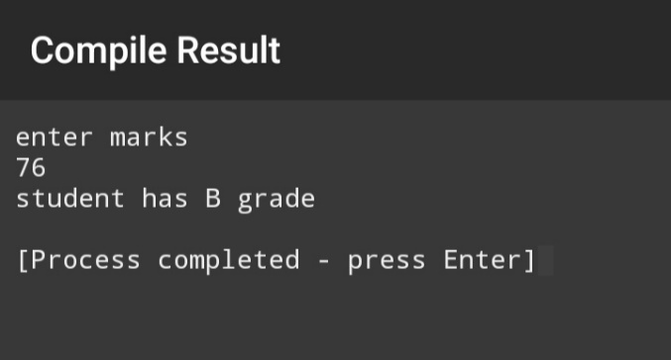 else{cout<<”student has E grade”<<endl;}// given the else condition

1. **Write a program that takes an integer as input and determines if it is both even and divisible by 5.**

**Code:**

#include<iostream>

using namespace std;

int main (){ int number ;// declared variable

cout<<”enter number”<<endl;// demanding input

cin>>number;// giving input

if(number%2==0&&number%5==0)// applying if condition

{cout<<”number is even and divisible by 5”<<endl;}

else if(number%2==0&&number%5!=0)// applying else if condition

{cout<<”number is even but not divisible by 5”<<endl;}

else if(number%2!=0&&number%5==0)// applied another else if condition

{cout<<”number is divisible by 5 but not even”<<endl;}

else{cout<<”number is neither divisible by 5 nor even”<<endl;}//applied else condition

}

**Output:**

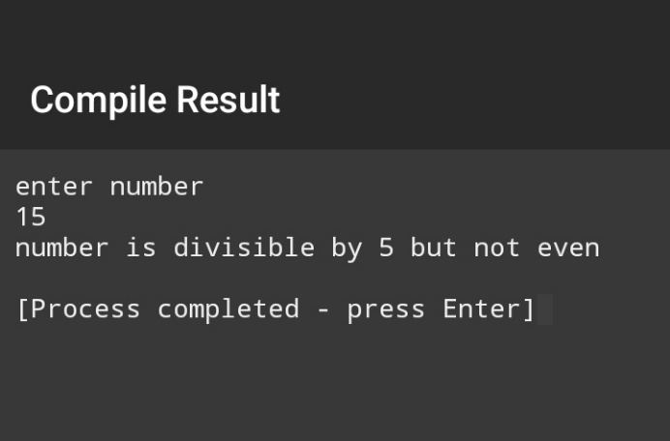

1. **Create a C++ program that checks if a user-provided year is a leap year**

**Code:**

#include<iostream>

using namespace std;

int main (){ int year;// declaring variable

cout<<”enter year”<<endl;

cin>>year;

if((year%400==0)||(year%4==0&&year%100!=0))// applying the if condition for leap year

{cout<<”year is leap year”<<endl;}

else{cout<<”year is not a leap year”<<endl;}// applying else condition

}

**Output:**

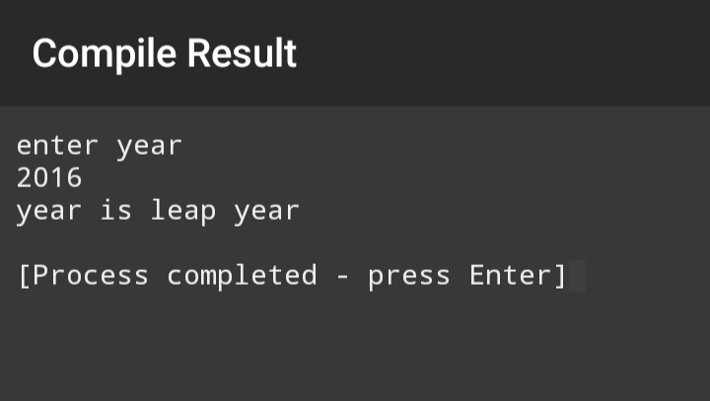

1. **Create a C++ program that determines if a student is eligible for a scholarship based on their GPA (must have GPA >= 3.5) and attendance (must have attended at least 80% of classes).**

**Code:**

**#i**nclude<iostream>

Using namespace std;

int main(){ float GPA,attendance;// declaring variables

cout<<”GPA of student is “<<endl;

cin>>GPA;//entering first input

cout<<”percentage of attendance of student is”<<endl;

cin>>attendance;//entering second input

if(GPA>=3.5&&attendance>=80)// applying if condition

{

cout<<”student is eligible for scholarship”<<endl;}

else

{ cout<<”student is ineligible for scholarship”<<endl;}// applying else condition

}

**Output:**

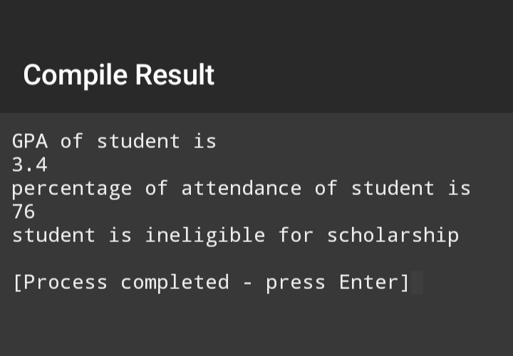

1. **Write a program that checks if a given character is a vowel (a, e, i, o, u) or a consonant using logic operators.**

**Code:**

#include<iostream>

using namespace std;

int main() { char alphabet;//declaring variables

cout<<”enter alphabet”<<endl;

cin>>alphabet;//giving input

if(alphabet==’a’||alphabet==’e’||alphabet==’i’||alphabet==’o’||alphabet==’u’)//applying if condition

{cout<<”alphabet is vowel”<<endl;

}

else

{

cout<<”alphabet is consonant”<<endl;}//applying else condition

}

**Output:**

